Table of Contents

**INTRODUCTION**

What is Programming?1

Program used in this Project2

**PROBLEM**

Problem Definition3

Problem Solution4

**LISTING OF PROGRAM**

Hardcopy of the Program0

Description of Program0

**Introduction**

**What is Programming?**

Programming is the process of performing a particular computation, usually by designing and building an executable computer program. Programming involves tasks such as analysis, generating algorithms, algorithms' accuracy, etc.

Programming can be written using varies programming languages. Some popular programming languages are:

* Java
* Javascript
* Python
* PHP
* C#
* C
* C++
* SQL
* HTML
* CSS

**Program used in this Project**

The program used to code this project was Visual Studio Code (VS Code). VS Code is an integrated development environment from Microsoft. It is used to develop computer programs including websites, web apps, web services and mobile apps. It can support all the popular programming languages including Python and Java.



**Problem**

**Problem Definition**

The program that I developed is a space game about a space traveler who has a mission. His mission is to make it and land on Europa (Jupiter’s Moon). But he first must travel from Earth to Mars and from there he has to travel across 100 asteroids, meanwhile he has several random chances of being teleported by wormholes to the Sun, an unknown area of the universe, or get hit by a meteoroid. If so, he’ll have to get back to Earth to repair his ship. At the end of the day his mission is to make it to Europa in one piece!

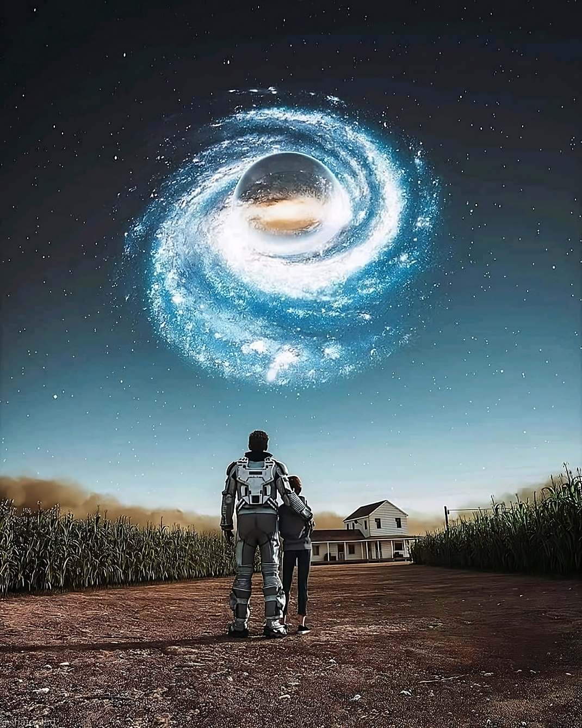

**Problem Solution**

Flowchart – Main Menu

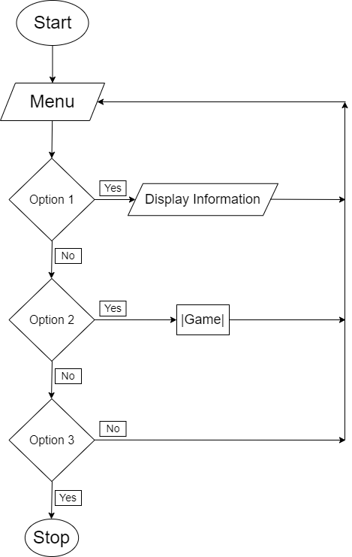

Flowchart – Game Method